台灣傳道六十年紀念特刊支分會專用稿紙 (寫好後請寄給梁世威弟兄 Carlliang05@gmail.com，手機0928-244715， Skype: carlliang3151，Line ID: carlliang)

單位名稱 | 金華支會 |  | 單位號碼  71579
單位資料 | 成立日期 | 西元 1958年 月 日台北分會
 | 原屬單位 | 1961由北台北分會(78557)和南台北分會(77984)分出西台北分會  1968 西台北分會關閉併入東台北分會(78557)  1971 重開西台北分會  1976.4.22 更名為台北第二支會  1998.5.24 由西台北支聯會轉隸中台北支聯會  2009.12.27 邊界變更並更名為金華支會
 | 教堂地址 | 1958 台北市中山北路 (見1959年5月聖徒之聲第23頁)  1958 台北市貴陽街一段56號  1960 台北市新生南路一段148-1號  1964 台北市10642大安區金華街183巷5號
 | 教堂電話 | 02-23218352
 | 歷任主教/會長(從第一任開始) | 1957 Stanley Simiskey  1957.5.3 Lyle Simonson  1958.4.13 Elder Kitchen  1959.3.1 尼爾遜長老  梁潤生  1961.4.30~ 胡唯一  1976.4.22 (台北第二支會) 姚舜  1981 梁世威  1982.9.19~1984.1.15 曹達安  1984.1.15~1987.1.6 葉國泰  1987.1.6~1990.9.30 林春水  1990.9.30~1993.11.28 梁世威  1993.11.28~1999.2.21游文彬  1999.2.21~2006.5.28王名儒  2006.5.28~2013.7.14劉常修  2013.7.14 賴明君
重要史料 (請勿超過1,500字，所撰寫之資料請盡量包含人事時地物五大要項。 請附寄現任主教/會長照片及教堂照片。從前教堂及領袖之照片及重要活動史料照片亦很歡迎， 用畢歸還。)

1956.6.23 由南遠東傳道部席德恩會長成立台北分會
1958.4.28 曾翼璋弟兄成為第一位本地的麥基洗德聖職長老
1959.3.1 尼爾遜長老擔任會長 (Thomas P. Nielson, 即以後之台北傳道部會長及台北聖殿會長)
梁潤生出任第一任的本地教友分會會長
1959.1.17 成立台灣第一個婦女會，會長陳林淑良姊妹，一副陳顧翹珍姊妹，二復袁宋文娟姊妹
1960 分為南台北分會及北台北分會，原台北分會更名為南台北分會
1961.4.30 南台北分會會長團會長梁潤生、一副陳孟猶、二副胡唯一卸任，由胡唯一接任會長。北台北分會會長為林存斌。
1961.4 分出西台北分會，聚會地點為台北縣中和鄉中和路78號之A
1962.3. 林存斌擔任南台北分會會長
1962 台北金華街教堂動工
1966 金華街教堂奉獻，東台北分會及西台北分會遷入聚會
1972 關昭擔任東台北分會會長

歷史悠久的二支會

教會的發展從1956年6月首批傳教士到台灣展開傳道事工開始，不久即成立台北分會，首任會長為Stanley Simiskey，1958年本地首任會長為梁會長潤生弟兄；在1964年11月17日成立北、中、南三個區會，會長分別為梁會長潤生弟兄、翁會長明燦弟兄、賀會長勝定弟兄；於1976年4月22日成立台灣台北支聯會（此乃全台第一個支聯會），首任會長為張會長漪清弟兄；1982年台北支聯會分為西台北與東台北支聯會，首任會長分別為劉會長春華弟兄與嚴會長元琥弟兄；到了1998年5月24日由東台北與西台北支聯會再行分出中台北支聯會，其會長分別為仲會長國強弟兄、楊會長宗廷弟兄、曾會長水田弟兄。台北二支會則是中台北支聯會之一。
在這10年裡，二支會因教堂的改建而從舊教堂搬遷至臨時教堂，之後因新教堂的興建完成再度遷入舊址。歷來的主教是游主教文彬弟兄（1993年11月~1999年1月）、王主教名儒弟兄（1999年1月~2006年5月）、劉主教常修弟兄（2006年5月~ ~）。

本教會特殊之處

我們教會的特色是，家庭是永恆的、可以永遠在一起，不因今生生命的結束而結束；有別的地方沒有的經文，如摩門經、無價珍珠、教義和聖約與先知的話語--利阿賀拿，特別是沒有付錢的聖職人員，大家都是義工；有活著的先知來帶領，他是由神所揀選的。
洗禮與神立約，接受了聖靈的恩賜，為了享有聖靈的終身為伴，必須終身保持配稱。因為聖靈對於我們有聖化、潔淨的影響，幫助我們認識真理、提供靈性的力量、協助我們去做正確的事、在面臨考驗或悲傷時安慰我們、遭遇困難危險時適時地警告我們，透過聖靈的力量，我們可以感受到神對我們的愛與指引。

三任主教談十年史（1999-2008）

在游主教期間，二支會早期最大的團體是單身成人，與年長的老教友家庭，中間的年輕家庭較少。因為單成的活躍，游主教鼓勵單成為主服務--去傳教，那段時期曾有八位教友出去傳教，六位在國內兩位在國外服務。
搬遷至臨時教堂後，家庭的加入越來越多，使得各個的附屬組織更完全，不必擔心人手不足的問題。王主教分享在我們需要的時候神都會給予適合的人選、做適當的事工、給予適當的祝福。我們有教齡非常資深的教友，他們是我們的寶、是我們的榜樣，他們持守到底用他們的行為表率出來，晚輩們可以依循其模式--信心、希望、博愛、愛心、耐心、勤奮、知識、美德、服從、服務、謙卑的持守到底走在這直而窄的道路上。
二支會向來有著許多很好的傳承，例如男女青的晨間福音進修班、父親節母親節的活動、聖誕節的年度回憶、戶外的大地活動。最特別的是每次的活動從沒有淋過雨，能夠感受到神是多麼的愛我們，給了我們這麼多的奇蹟；現在感恩節的聚餐人數可以達到兩百多人。劉主教說辦活動要精簡、要合乎特定的需求，而不是為活動而辦活動。好比家庭是一個很好的傳承，會為了照顧每個家庭成員的特別需求去處理，大家也都能從活動中學習到服務犧牲所帶來的快樂，例如社區的服務、聖誕節的報佳音。
游主教與教友面談時常分享、鼓勵的經文，腓立比書4：4-7---喜樂、謙讓的心；如果我們因為挫折而傷心、因撒旦的誘惑而墜落，真的會中了撒旦的計量；我們要快樂，要在考驗中得到進步，考驗是神賜給我們進步的機會，所以我們要常喜樂，對所有的苦難，我們要把它看成是神賜給我們進步的機會。
王主教最喜歡阿爾瑪書32：41---憑信心、努力、耐心加以培植。知道天父祂非常的愛我們，真正有準備好豐盛的宴席在等著我們，端看我們有沒有聽神的話，在做任何事的時候，有沒有都考慮到神是怎麼看這事，我們有沒有在家人、家庭中真正帶領走在這條正義的道路，做好行為榜樣，讓這棵永恆生命樹成長。
劉主教認為每位主教都有其特定的召喚、任務，應盡自己之責努力去做不拖延，如阿爾瑪書34：32-33---努力不拖延，為永恆做準備。期望能幫助二支會達到聚會人數200的目標使之越來越進步、協助教友達成其目標、鼓勵男女青年做好準備將來去傳教。

二支會婦女會的改變

二支會婦女會的組織是希望能聯繫姊妹之間的情誼、了解母職的重要、可以在家政技巧上、興趣發展上相互提攜、有探訪病患、協助貧困的人，了解他們的需要，紓解他們的困境，所以有探訪教導與充實聚會。
在充實聚會裡可以彼此分享經驗提昇靈性，也可增加家政的技巧，自2006年1月起改成家人家庭及個人充實聚會，在時間、型態上可依規定加以調整後更顯得多樣化。每次計劃下年度時，都會事先透過問卷調查，設計適合家人家庭個人參與的活動如健康系列、DIY系列：拼布、水晶飾品、手工卡片，美姿系列：造型、保養、彩妝、美髮、染髮、編髮、剪髮，美食系列……等。
不只肚子吃得飽飽的，在靈性上也獲得滋潤，也讓家中非教友的家人，透過充實聚會輕鬆的活動、愉快的氣氛，來了解家人在教會裡的成長、讓他們也能認識教會。使得教友、姊妹間的情誼更增進，不但在工作、生活上獲得助益且可互相切磋彼此的家政技巧，做事的方法，且可激發其靈感，並可將這些所學的才華應用於工作、家庭生活上。
姊妹分享我們唯一可帶到來世的，就是在今生中所培養的各種才能，姊妹們可以在婦女會的課程教導裡、充實聚會的活動中學習福音原則、做事方法、各項才能、發展才華，並配稱保持忠信地持守到底，藉以榮耀神。
探訪教導是希望彼此相互的照顧分享，解決生活上的問題。對於新加入的姊妹會立刻安排探訪教師，協助她們的需求。在婦女會課程的設計上，以往是以後期聖徒婦女課本為主，現已改成總會會長的教訓，第一週是靈性課程由會長團們負責，第二、三週是上總會會長的教訓，第四週上的是利阿賀拿，是有關總會教友大會時的訊息，幫助我們學習先知的榜樣，更加接近神。
在教會辦活動是件很受祝福的事，只要用神的方法，做對的事情，結果一定會很好。我們二支會是個成熟的支會，不但資源多，姊妹們也都願意伸出援手來支援活動，使得父親節的戶外活動、支聯會的活動、充實聚會的活動，或是聚餐，都能圓滿順利的達成目的。

活動帶動兒童們的成長

二支兒童會的特色是，弟兄比姊妹多。在教導上，教師們都很有耐心的一次又一次不斷地重覆教導。2004年7月於青青農場舉辦兒童會活動日。在這次的活動中，我們希望孩子們能體會到父母親們的辛苦與對孩子們的愛，因此設計了這個角色互換的活動，小孩變成了大人；而大人們則成為小小孩。
角色互換的大人該如何去照顧他們的組員--小小孩，如何為他們的小小孩準備食物、飲用水及日常所需，照顧安慰這些小小孩，確實讓孩子們體會到成為大人的不易，不是只有自己吃飽、自己好而已，還需考慮到伴侶、家庭成員每一個人的所需及人際關係的相處。在這次的活動中，孩子們學會了照顧人，也讓父母們更加的了解自己的小孩及一個難忘的假期。
2005年7月8日，晚間時刻在大溪地度假村揭開序幕，活動內容最特別的是「廚師小當家」，在這個活動中，兒童們個個使出渾身解數，利用既有的食材為父母親和老師們料理出美味、豐盛的午餐；父母、教師在享用兒童們努力準備的食物時，臉上都洋溢著滿足的笑容與感謝，畫面溫馨感人。在這次活動中，我們感謝有這美好的大自然提供家庭休憇及娛樂，讓平日繁忙的家庭有一個特別的機會與家人們同樂、從事良好的休閒活動。

唱詩班的成立

二支會的唱詩班，自從音樂主席吳黃鳳英姐妹於2004年7月被召喚之後，仔細研讀手冊之後，她知道每一個支會都應該有一個積極的唱詩班，這個信念驅動她去推動二支會唱詩班的成立。剛成立的時候，沒什麼人要來練唱，於是鳳英姐妹努力拜託教友們來練習，並且分部錄好錄音帶，讓教友們即使無法來練唱也可以在家練習，她的熱情無形中感動了許多的教友，也推動了主的事工。透過每個月一到兩次聖餐聚會的獻唱，越來越多的教友主動並穩定的參與唱詩班的練習。唱詩班的成立，讓許多夫妻在家中也能練唱，感情更融洽；詩歌的背誦，也讓唱詩班的成員，在面臨考驗的時候，腦海中自然浮現的詩歌詞句，幫助他們渡過了考驗。音樂的薰陶，豐富了教友的生活，也增強了教友們靈性的力量。

十年內受洗的教友見證

- 吳逸君家庭

吳逸君弟兄於1999年4月24日於台北金華街舊教堂洗禮。雖然身為基督徒，但是由於信仰上許多問題無法從牧師獲得解答，驅使夫妻倆追尋真理的渴望。直到傳教士姐妹來家中敲門，太太吳黃鳳英姐妹，因為聖殿的教義，獲得了啟示與見證而率先受洗，在她不斷為丈夫吳逸君弟兄的禱告之下，吳逸君弟兄也終於獲得了個人的見證，他說：「受到過去基督教會對我們教會的批評，在我心裡一直有根深蒂固的觀念，讓我無法突破異端的想法。直到永恆家庭的教導，終於突破我的心防。」五個孩子，是吳逸君家庭最大的幸福來源，吳黃鳳英姐妹說：「加入教會感受最深的就是，從昊禎、霽庭、奕潔、承恩到立恩，孩子一個接一個來，如果我們沒有加入教會，我會去發展事業，當一個職業婦女。但是神知道我的生活怎麼過最好，讓我當一個全職的母親，雖然很辛苦，但是快樂加倍！前幾天我們家老二霽庭才說：『如果我們沒有加入教會，我跟哥哥現在一定會在電腦桌前啃麵包，因為媽媽在上班。』」

- 郝廖苗君姐妹

郝廖苗君姐妹於2001年12月8日於台北金華街舊教堂受洗，在接受福音的
六年多當中，從單身到去傳教，並於今年1月1日與返鄉傳教士郝衛岸弟兄於台北聖殿締結永恆婚姻，能夠在短短六年多培養堅強的見證，最重要的是二支會擁有眾多返鄉傳教士的美好榜樣與鼓勵，以及先驅者教友們堅強信心的榜樣所感動，以及歸信期間，看見二支會眾多堅強家庭的榜樣，培養永恆婚姻的渴望。最後郝姐妹想對二支會的教友說：「能在二支會從單成、傳教到結婚，真的是一件很幸福的事情！」

- 吳順治家庭
吳順治家庭於2003 年7月19日於台北羅斯福路臨時教堂接受洗禮，回憶起在商業大樓內，樓梯間搭起充氣式洗禮池的洗禮經驗，吳林淑玲姐妹忍不住笑著說：「因為我不會游泳，掙扎了三次，才終於洗禮成功！」2003年吳順治弟兄腿部意外扭傷，整個暑假都在家裡，碰到傳教士開始上課，很快的在一個月全家接受洗禮。吳弟兄說：「雖然才短短兩三個禮拜，我們都感覺家庭氣氛的改變，整個家庭有目標，渴望家庭能永遠在一起。」吳林淑玲姐妹說：「最重要的影響是傳教士的榜樣，我跟吳弟兄都在大學教書，面對的大學生，不是留長髮就是穿拖鞋，但是傳教士卻都乾乾淨淨的、很規矩、不講髒話，令我們印象深刻。」2005年8月9日，吳順治家庭一家四口，於台北聖殿接受家庭印證的祝福，回憶印證當時的感覺，吳姐妹印象深刻：「當我在聖殿裡面跪下來，我覺得自己怎麼那麼幸運？能夠有永恆的家庭！當時我的腦海不斷浮現出姊姊的畫面，他的家庭很不平靜，常常打電話告訴我要去跳樓，雖然帶他們來教會，他們卻無法接受這美好的福音，讓我深感兩個家庭強烈的對比。」最後吳順治家庭要感謝二支會的教友：「謝謝你們讓我們在二支會成長，一轉眼我們洗禮快五年了，在神的幫助以及各位的幫助之下，希望能持守到底，四十年之後再來拍我們！」

金華街教堂舊堂簡史 簡介方

台北市金華街教堂（舊堂）為台灣第一座自有教堂，是孕育北台灣多個支分會的搖籃。

早期教友先後於仁愛路、貴陽街、新生南路等地聚會，1960年代初期，教會有感於教友人數成長，亟需一座自有教堂供教友聚會崇拜之用，於是在多位領袖及教友的積極奔走下，於台北市金華街183巷內覓得一塊適合的土地。

這片土地為昔日台北監獄之園圃，佔地約五百坪，格局方正，位於金山南路後方之靜巷，左為天主教教廷駐華辦事處，右鄰政治大學公企中心，後方為淡江大學城區部，環境幽雅宜人。

當時擔任十二使徒助理的興格萊長老奉派主領亞洲事務，負責督導購買金華街教堂建地的諸多事宜，參與的本地教友則包括胡唯一弟兄等人。

1961年11月，教會順利購得土地之後，於1963年舉行動土儀式，當天儀式由十二使徒興格萊長老親自主持，參與的本地教友包括陳林淑良姊妹、車在田、林存斌弟兄等早期教友多人。

當時教會在台尚屬初創階段，教友投入無數心力、物資與金錢，全力協助興建工程，工程監督為美籍的隄柏斯弟兄。教會也召喚顏德標、陳武雄等數位弟兄擔任建築傳教士傾力協助，婦女會姊妹則幫忙紮鐵絲、刷油漆、洗窗戶。教友不分男女老幼都抽空到工地幫忙，王林道弟兄亦常自掏腰包請教友吃點心。

1960年代，教友生活清簡，無法支付龐大的教堂建築基金（當時使用教堂之單位需負擔建築費用的百分之二），只得以奉獻工（在工地工作一小時等於奉獻一元美金）的方式繳付。但到教堂竣工之際，仍因金額不足，無法奉獻。有鑑於此，當時的南遠東傳道部會長奎理（President Jay A. Quealy）慨然奉獻金錢，支付巨大差額，這座教堂始能順利進行奉獻。根據陳林淑良姊妹表示，奎理會長曾說：「下次我來教堂時要檢查！我會摸摸牆壁，看看是否有灰塵，也會摸摸長椅下面，看看是不是黏了口香糖。」

1966年，十二使徒興格萊長老再度來台，為竣工的教堂舉行奉獻典禮。

會堂落成後，傳道事工蒸蒸日上。1976年，台灣第一個支聯會於金華街教堂成立，首任會長為張漪清弟兄。1982年，台灣台北支聯會劃分為西台北與東台北支聯會，首任會長分別為劉春華及嚴元琥弟兄，金華街教堂成為西台北支聯會中心。1998年，東、西支聯會劃分為東、中、西三個支聯會，中台北支聯會首任會長為曾水田弟兄，金華街教堂成為中台北支聯會中心。

本座教堂平面呈十字形，藍色屋瓦在白色磚牆的襯托之下，樸素中見莊嚴。中央前廳為大會堂，是教友聚會崇拜、領受聖餐、聆聽演講的地點。曾蒞臨金華街教堂的教會領袖包括：戈登興格萊長老、壽白朗會長、布司麥康基長老、海樂李會長、馬文艾希頓長老、賓塞甘會長、豪惠洪德長老、達林鄔克司長老、羅素培勒長老、亨利艾寧長老、約瑟胡適令長老、多馬貝利長老、李察司考德長老等人。這裡亦舉辦過許多饒富意義的社區活動，包括邀請前內政部長林洋港先生蒞臨演講。

大會堂後方為康樂廳，是舉辦各式聯誼活動、婚禮、家譜展覽、大型會議、聖誕晚會的多功能場所。

這座教堂亦為許多機構的辦公室：1973年，教會教育機構成立於此，辦公室設於西側前方，首位協調員為郝弟兄（Alan Hassell）。西側後方為家譜中心，成立於1983年，胡紹祿弟兄、胡周悅影姊妹為首任的家譜服務傳教士，負責家譜及各項相關事宜。

東側為一般教室與洗禮池，是教友接受福音課程、受洗、立約進入神的羊圈的地方。地下室則有高級諮議室及兒童會教室。

有鑑於教友不斷增加，舊教堂又在防震方面已不符現代的標準，教會決定改建，2002年7月至8月期間舉行一系列拆建活動，包括取出鑲嵌於前壁基石內的「時光寶盒」、兒童彩繪教堂展、歷史圖片展、戲劇「誰拆了我的房子」、爐邊音樂會等等，並由王綠寶、黃念豫兩位弟兄製作教會簡史「思念、感恩、盼望」影碟，為金華街教堂的點滴過往留下珍貴紀錄。

隨著2002年8月10日的新教堂動土儀式，金華街舊堂功成身退，正式走入歷史，但永存於教友共同的記憶之中。

金華支會2011年歷史

金華支會2011年目標及實際達成一覽表
項目 | 目標 | 實際達成
聖餐聚會人數 | 200 | 200±20
洗禮人數 | 35 | 21
晉陞麥基洗德聖職人數 | 3 | 3
印證永恆婚姻人數 | 4 | 3
傳教人數 | 3 | 3
- 聖餐聚會人數：平均180人，最高達220人
- 洗禮姓名(先後次序)：劉祐安弟兄、蕭雅萍姊妹、莊舒媚姊妹、簡忠翔弟兄、郭佳姊妹、郭殷和弟兄、賴律齊弟兄、洪元怡姊妹、鄭雲靚姊妹、林周美君姊妹、陳泓齊弟兄、王佳臻姊妹、郭優姊妹、李鳳吟姊妹、董語涵姊妹、黃群倫弟兄、邱奕龍弟兄、林俊瑋弟兄、陳力慈姊妹、王惠玲姊妹、傅大銓弟兄
- 麥基洗德聖職晉陞：王國仁弟兄、何文嘉弟兄、黃柏霖弟兄
- 永恆婚姻：陳含羽姊妹、范玉玲姊妹、彭蓉香姊妹
- 俗世婚姻：吳家瑤姊妹、李佳霖姊妹、曹玉堂弟兄、梁建芸姊妹
- 返鄉傳教士︰邱上銘弟兄、吳惠輔弟兄、彭蓉香姊妹
- 新生兒︰梁左思弟兄、梁又和弟兄及陳昱璉姊妹
- 往生者：陳孟猶弟兄、劉育奇弟兄

ACQUISITION OF THE CHURCH ADMINISTRATION BUILDING – TAIWAN Paul Hyer
Building the Kingdom of God on the earth and the establishment of Zion is never easy. It was not easy in the meridian of time when the Savior walked the earth and when the Apostle Paul was working through the Jewish diaspora of Greece and Rome. It was not easy in the days of the prophet Joseph Smith or the days of the latter-day Moses, Brigham Young and my great grandfather, Christian Hyer – immigrant, convert, pioneer.
More particularly I have in mind my experience as mission president in Taiwan, China and one of our many problems, namely, finding a new mission headquarters. The story is detailed below. The result, one of my more important accomplishments in the mission, was finding and helping to acquire what is now our fine administration building for Church offices in Taiwan, China. I have already explained elsewhere my involvement in building the Temple.
When I arrived in July 1982 the Taipei mission headquarters including the residence of the mission president were located
where the temple is presently located. When I first saw the neighborhood almost twenty years earlier in 1963; it was open fields, a large gardening area of a Chinese prison. The old
stone wall of the prison is still there if a person knows where to look. The land was purchased for a chapel; what eventually |became the first stake center. Later, Malan Jackson, first president of an independent Taiwan Mission, contracted in 1972 to build a mission office and a mission president's residence just south of the stake center. At first his office was downstairs in the basement of the building, and the residence was out in Tienmu.
By 1982 the decision had been made to demolish the mission complex and build the temple on the site. It was then imperative that I find a new location for the mission offices and a
residence for the mission president's family – – a daunting task as it turned out . Daunting because the area was now saturated with two in-town university branches -- Tanjang University and
Chengchi University, also with government offices and many businesses.
We debated putting the mission complex out in the outskirts of Taipei in such a place as Shihlin or Tienmu. However, I wanted to keep the headquarters more in town, close to the fine Taipei Stake Center. This was the focal point of the Church in Taiwan, a facility role mission used on occasion and would be close to the temple j would soon be built.
We looked carefully around the area for a new location for the mission headquarters but the search was rather discouraging. The mission office elders were assisting and found a suite of
offices near the stake center, just off Hsinyi Road that seemed to be a possibility. But the space was on the 6th floor of the building and Salt Lake said we could not put a mission headquarters on the 6th floor of a building. I think they had in mind the problems of heavy personnel traffic on an upper floor. We did look at a piece of Church owned ground in Shihlin that was vacant and where we could build an appropriate building. But the place was ideal for a chapel, one was needed in the area and again I wanted to keep the mission close to the church Center.
I was beginning to despair of finding a suitable place when one day I leaned back from my desk and looked sideways to my left out the back window of the office. There on "Alley" #183 coming off of Chin-hua street T noticed a seven story building going up. The location was ideal and I wondered what it was planned for and who owned it. Would it be a possibility to meet our needs 2 I remember the general development of the events that followed though now, without my notes and after seventeen years, my recollection is not clear on every detail.
I remember asking one of our Presiding Bishopric Office (PBO) personnel, Stephen Wong, to enquire about the building and see if there was any possibility for us to obtain space there. He followed through and found that there was . This was a ray of hope. The pressure was on to move the mission headquarters and clear the way for the demolition of our mission buildings so the construction of the temple could proceed. It was urgent for us to make some critical decisions.
We learned that the building that had attracted my attention was being constructed by a family company as a combination of offices and family residence. The quality of the work on the structure was superior -- it was not being built for speculation sale or investment. They were willing to lease us four floors of the building, furthermore, they were willing to consider giving us an option to buy the entire building. We informed the Brethren in Salt Lake of what to us was an inspired situation, a heaven sent opportunity.
Fortunately, the Lord brought to us just at the time two men who were important in the process concerned here, Marvin Jensen and Elder David Melson. Though it was necessary for me to be involved in the process as Chairman of the Church Corporation in the country, I was busy with many responsibilities more especially concerned with supervising the missionary zones and districts, the proselyting work and two districts of Chinese branches and members.
I digress here to introduce Elder David Melson. He was the person to design the layout for the mission headquarters, to supervise the move, and be of help in other aspects of the
mission. He was twenty-nine years of age, a convert of just over a year. He was a confident, mature, capable person who had managed a hotel and had other useful experiences. Interestingly, as a new missionary he had been one of my counselors while I was serving as a branch president at the Mission Training Center (MTC) . This was before any thought or call for me to serve as mission president
Elder Melson was called to the Taichung Mission but while serving there he did not make progress in learning Chinese. It appeared that his mission would not be a good experience in China so he was transferred to the Philippines where English was adequate for the work. There he had been very active in some changes and in setting up a new mission headquarters. So active it appears in taking the initiative that the mission president
was uneasy.
When Elder Melson learned that Paul Hyer was called to Taiwan he decided that he also had really been called to Taiwan and he wanted to return. He lobbied with the visiting general
authority – – Elder Robert L. Simpson, Executive Administrator,
(this was the office over missions and stakes before the Area Presidency system was instituted) . Elder Simpson left the
Philippines for Taiwan and I picked him up at the airport. As we drove into town he brought up Elder Melson's situation and asked me how I would feel about having him transferred to my mission. I said it was agreeable with me and the transfer was made. Elder Melson was a great help in many ways. His maturity was helpful in counseling young elders in their stressful mission experiences.
More important was the arrival of Marvin Jenson, a construction specialist who came to supervise the building of several chapels we planned. He was especially important in drawing up a detailed, special proposal for the purchase of the building in question here, giving attention to such matters as the finances and space utilization of the new building. This was necessary to persuade the Church to purchase it which proved to be the most difficult part of the process.
One advantage in Our favor in persuading Salt Lake to purchase the building, in addition to the urgency of moving the mission complex, was the fact that our various church offices were dispersed in several places in Taipei. The Distribution Center (Fashing-jungshing) for church literature, missionary tracts and many other supplies was located on Ho-ping East Road. The Translation Office and Finance Office were located up on Hsin-yi Street. Both were some distance from the mission headquarters and the stake offices. It would be much more ideal to have them brought together and consolidated in one place.
A very complicating factor was that the owners of the
building were hard bargainers. They frankly pointed out that the value of their building was considerably enhanced because of the fine LDS Church stake center just across the street and the new temple being constructed next door. Their asking price as I recall was near the cost of the temple. We had a series of dinner meetings with them to negotiate the matter but were not making much progress in lowering the price.
Salt Lake said their price was excessively high. Öne problem was that estimates of the worth of the building were made by Taiwan bank appraisers who are very conservative and came up with excessively low appraisals. Thus when Church staff in Salt Lake saw the large gap between the high value the owners were asking and the value the appraisers assigned the property, our problem was complicated.
Then Marvin Jenson got the idea to get appraisals by engineers as to what the cost of replacement of the building would be. These were more acceptable but still too high for Salt Lake, meaning the international Presiding Bishoprics Office (PBO) staff who carefully went over proposals before they were sent up to the Church appropriations committee – – essentially the Quorum of the Twelve. The PBO people were not supportive. Naturally their stewardship was to carefully husband the tithing funds of the Church.
With a lease arrangement we had already moved the mission headquarters into the fourth floor, the office staff living quarters occupied part of the fifth floor, and our family quarters were on the sixth floor and the kitchen, reception area, bedrooms for transient missionaries and the like were on the seventh floor. But the negotiations were pretty much at a stalemate, they had dragged on for several months and the out come was not encouraging.
Finally, the owners were getting impatient, were questioning the seriousness of the Church, its "sincerity" in purchasing the building. They informed us that if the purchase Was Idot resolved very soon they were going to move in and occupy the building which would probably be the end of our chances for a purchase
I was informed of their decision and decided to telephone the Brethren in Salt Lake. Following the line of authority, I contacted my Executive Administrator, Elder Simpson. I reported that we were going to loose the building if we did not act quickly and get an approval to purchase it. I was told that the proposal could be sent up again but that there was not much hope for a favorable decision – - the PBO people were not supportive of the proposition.
President Hinckley was conducting the meeting of the
appropriations committee that would make the final decision, the
A
crucial hurtle. This committee, I understand, includes the First Presidency, the Twelve, the Presiding Bishopric and probably others. The results were usually confidential but I was informed of how the meeting went by some source now forgotten.
President Hinckley asked how many of the committee favored "the purchase of that administration building in Taipei?" -- not many hands went up. Reframing the question he asked how many present were opposed to the purchase of the building in Taipei. Again, not many hands went up.
At this point "Mr. Asia" miraculously saved the day. Gordon B. Hinckley for years has been the widest traveled and the best informed of the Brethren on Asia. He said, if there is not so much opposition to the purchase, then why don't we buy it? The committee then fell into line and we gained an important and wonderful administrative building.
Belatedly, several Church leaders came to Taiwan, mainly in connection with the construction of the temple, and as they surveyed the situation, including the new building we had purchased, the were very pleased. They noted that we would never have to apologize for the purchase. It would have savęus much concern if they would have come earlier to see what we were proposing.
The building now houses, among other operations, the Translation Department, Distribution Center, Church Records office (that for a long time was in Hong Kong), Physical Facilities offices, Finance Office, a computer specialist, the Temple President's residence and the mission headquarters noted above.
We now have a complex of buildings in Taipei of which we can be proud. The administrative headquarters for the entire Republic of China, Taiwan plus the temple and a fine stake Ceriter . They are also quite well framed by surrounding properties to form an LDS oasis - – Taipei Temple square. This is important in a Chinese environment because we are judged by the physical appearance of our headquarters. OT OUT SaS to S TI flank as a background is the fine multi-storied building of Tanjang University . On our southern flank is another multistoried building of the branch campus of Chengchi University. On the northern perimeter is the fine Catholic complex of the Vatican Embassy and an impressive chapel. On the western side completing the circle is the administrative building discussed above.
It is an attractive group of buildings of which we can justly be proud. They give the Church visibility so people know that the LDS Church has an impressive presence in the capitol city of Taiwan, Republic of China. Evidence of this is that after the temple was dedicated in 1984 it was nominated as the
building of the year or one of the most beautiful buildings in
Taipei . It had attracted considerable attention, especially among architects. However, the temple was dropped from consideration because it is closed to the public – – interested
persons cannot freely enter in and wander around.
Moreover, these buildings, the temple, the stake center and the administrative building greatly enhance the work. W i t h changing conditions and the astronomical rise in the cost of real estate, the value of the building is now much greater than the price for which we purchased it. The saints in Taiwan, China and I owe President Hinckley a great debt of gratitude. He has always been a champion of the Church in Asia.

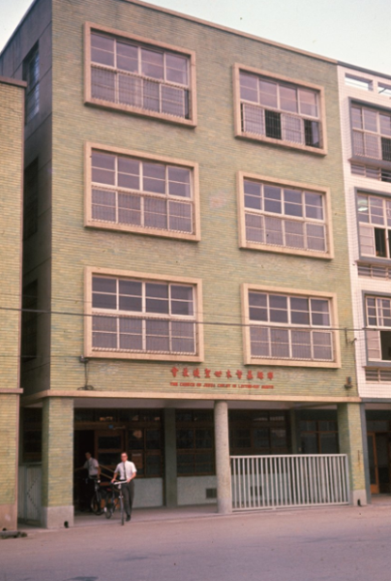
台北市新生南路一段148-1號
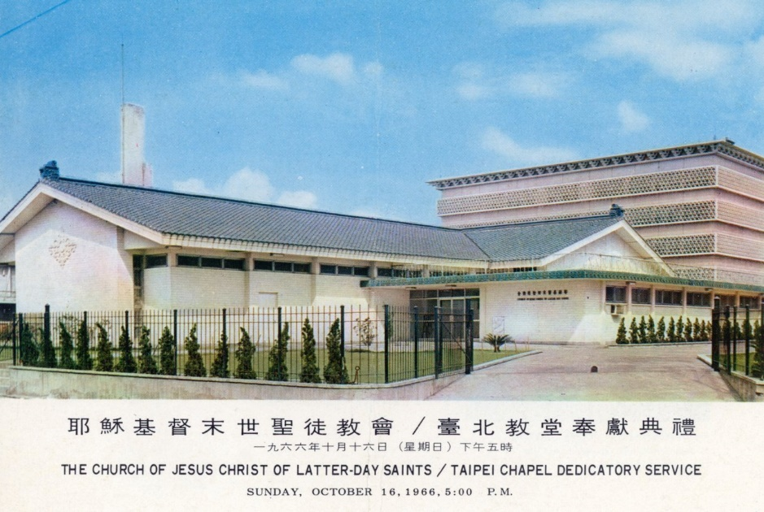

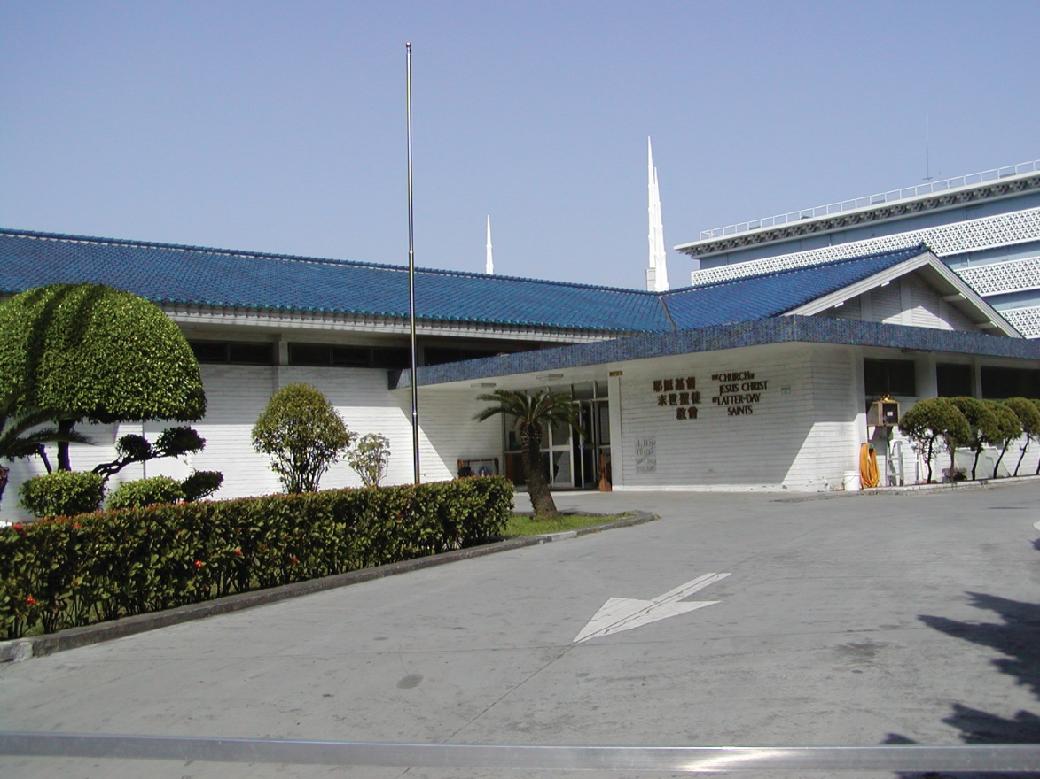
台北市金華街183巷5號 舊教堂 1964完工， 2002年功成身退
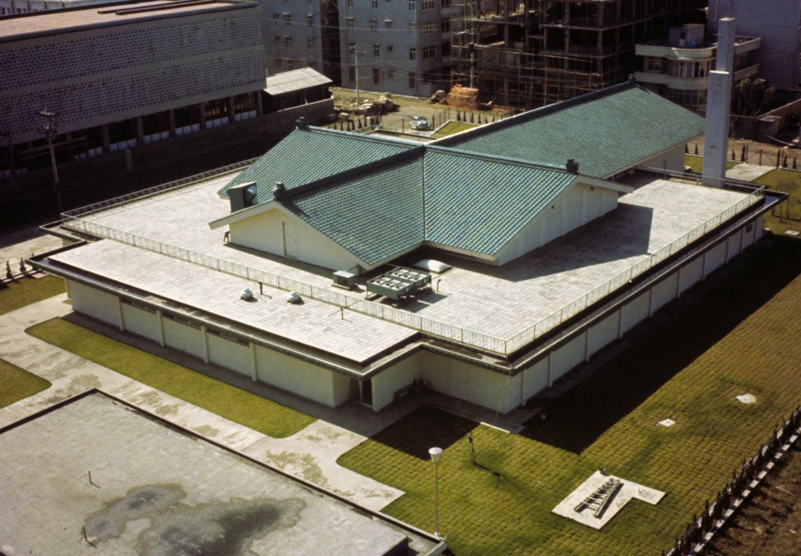

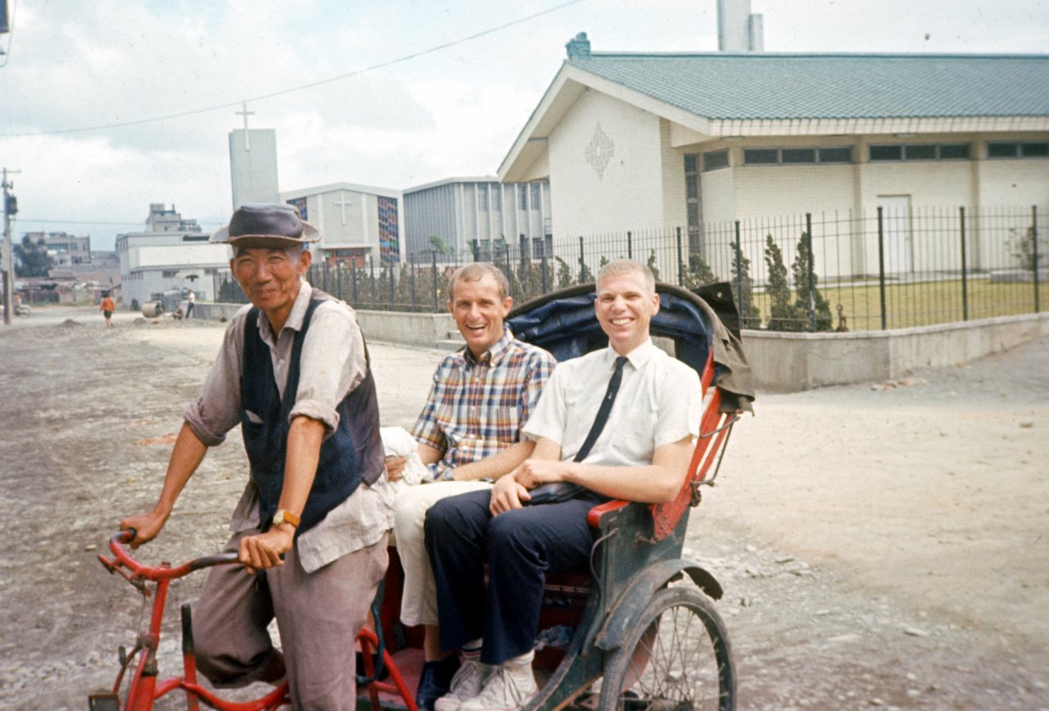

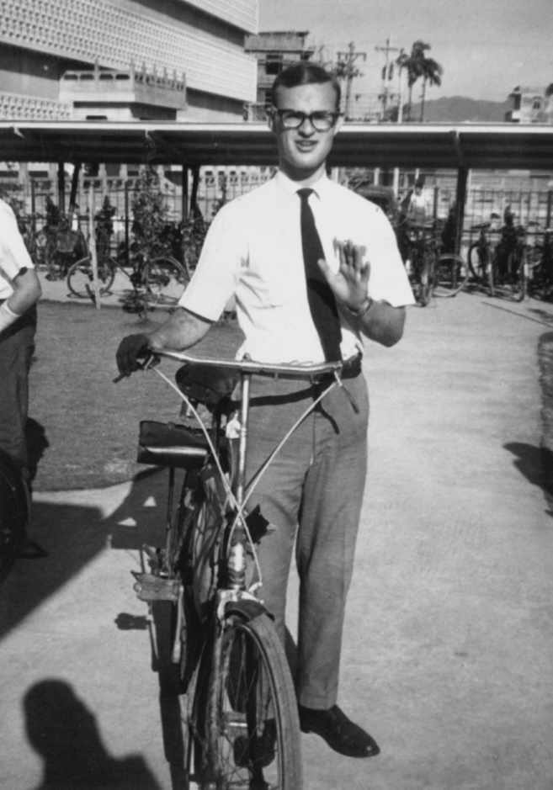
車棚
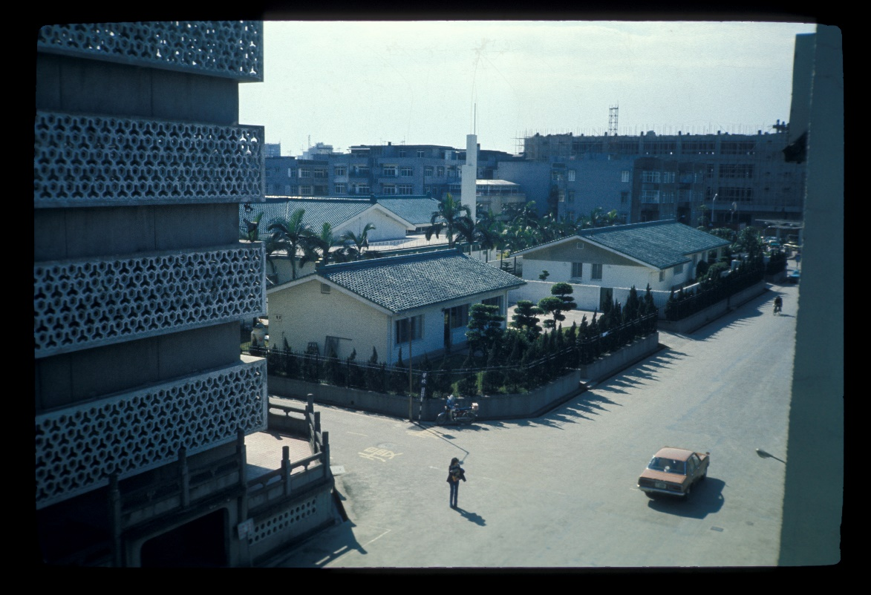
金華街教堂-1977-Brad Davis提供
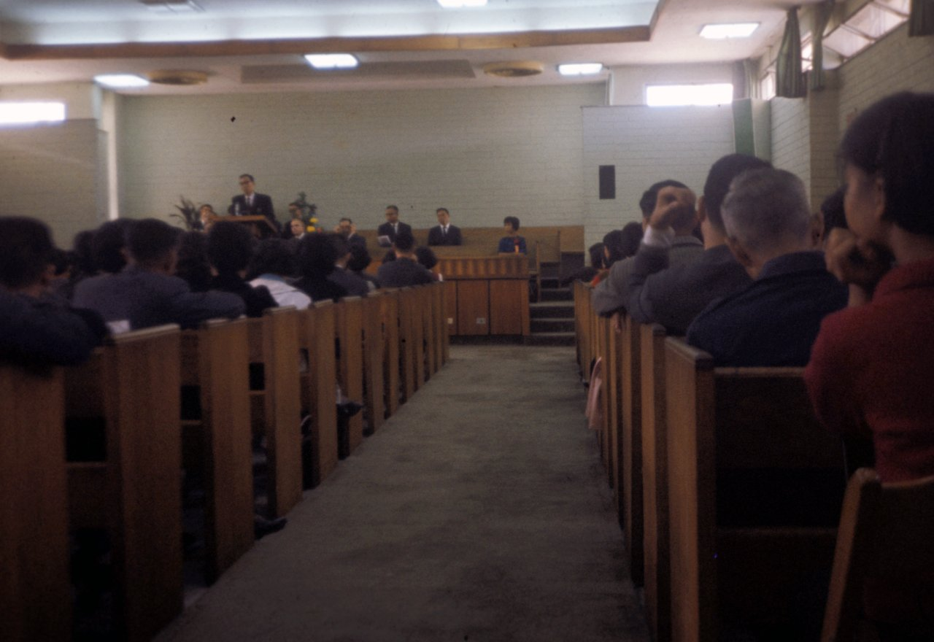

重建期間租用教堂， 2002/8/4~2004/12/31
Address : 台北市羅斯福路二段100號二樓

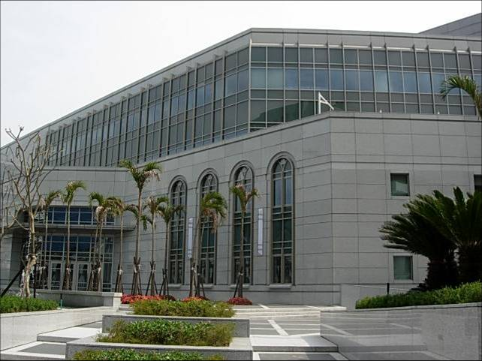
金華街教堂 – 2015年1月2日啟用，8月由興格萊會長奉獻
台北市10642大安區金華街183巷5號

補充資料提供者姓名： 電話： Email：

