台灣傳道六十年紀念特刊支分會專用稿紙 (寫好後請寄給梁世威弟兄 Carlliang05@gmail.com，手機0928-244715， Skype: carlliang3151，Line ID: carlliang)

單位名稱 | 新竹第二分會 |  | 單位號碼
單位資料 | 成立日期 | 西元 1997年5月4日
 | 原屬單位 | 新竹第一分會
 | 教堂地址 | 新竹市經國路一段442巷9號
 | 教堂電話 | 03-5325673
 | 歷任主教/會長(從第一任開始) | 1997.5.4~2002.3.31 DAVIS, CECIL E  2002.4.12~2006.6.30 王泰清
重要史料 (請勿超過1,500字，所撰寫之資料請盡量包含人事時地物五大要項。 請附寄現任主教/會長照片及教堂照片。從前教堂及領袖之照片及重要活動史料照片亦很歡迎， 用畢歸還。)

新竹分會於1979年8月8日成立，在1997年5月4日劃分成為新竹一分會及新竹二分會，其中新竹二分會為英語分會。
2010.7.25 新竹第二分會 (英文分會) 併入竹北第一支會

The Hsinchu Second Branch serves English-speaking members
living in the Hsinchu area. The branch was established in 1996 when Brother Cecil Davis from Idaho was called to be the branch president. He organized the branch under the direction of the Taichung Mission and Hsinchu District Presidencies. In its earliest days, missionaries
served in the branch presidency, under President Davis, and they also helped with the teaching of lessons. It is a very unique branch in the Hsinchu Stake. Most of its members are foreigners, many of whom found the Gospel after living in Hsinchu awhile. There is a great flux of
members in and out of the branch; most return to their home countries after a few years of employment here. They take the seeds of the Gospel back home, to their families in the Philippines, Indonesia, and Japan. The branch also has Americans, most of them long-
term members, and local Taiwanese members who have English language skills. The Taiwanese members volunteered to join the Hsinchu Second Branch, to strengthen and support its leadership and auxiliaries.

The current Branch President is President Arthur Wang. He has been serving since Mar 31 2002. His first counselor is President Michael Jenks and the branch clerk is Brother Bill Yu.

There were about 50 members in Hsinchu Second Branch. The monthly attendance rate is quite high, at 70% and greater. The branch meets the needs of its members: gospel instruction, friendship and support, and a sense of “family” and belonging. Members are strengthened through activity and by magnifying their callings. The Lord
never fails to support and bless the branch and the efforts of its members.

There were 13 children in the primary program. Sister Theresa Jenks is the Primary President; Sister Michelle Wang is the first counselor;
Sister Kelly Reynolds is the second counselor. There is a nursery class, Sunbeams, and Valiant class. There is sharing time and music instruction. Young Women and Young Men programs will be established in the summer of 2005, to meet the needs of an American family who will be moving to Hsinchu from China. There are 24 sisters in Relief Society. Sister Pam Chen is the Relief Society President;
Sister Lisa Patong is the first counselor; Sister Olive Salcedo is the second counselor; Sister Janice Tomelden is secretary. The sisters love
and care for each other and give support and assistance to those in need. 80% of the sisters attend R.S. meetings and/or Enrichment each month. This shows a great level of commitment to the Gospel, as most
of the sisters work very long hours (many work 12-hour night shifts) and transportation to church may be difficult or expensive. The sisters are
enthusiastic about sharing the Gospel with their friends and family members.

Thomas Chen is the President of the Elders Quorum. He is assisted by his first counselor Blake Lee. There are 9 Melchizdek priesthood holders now all active and serving this branch with their dedicatory hearts.

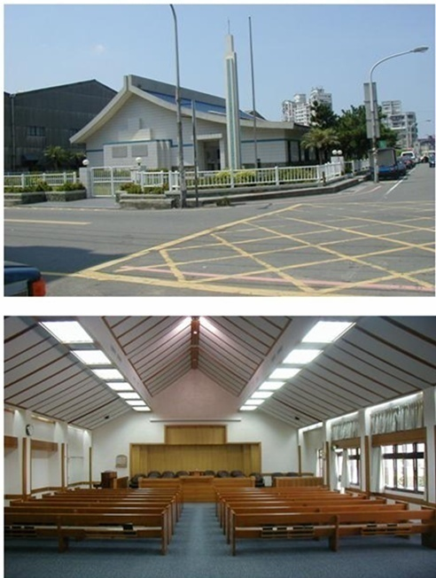
新竹教堂 – 1993年落成，1995年奉獻，1999年擴建
新竹市300經國路一段442巷9號

補充資料提供者姓名： 電話： Email：

