台灣傳道六十年紀念特刊支分會專用稿紙 (寫好後請寄給梁世威弟兄 Carlliang05@gmail.com，手機0928-244715， Skype: carlliang3151，Line ID: carlliang)

單位名稱 | 台灣台北傳道部 |  | 單位號碼  2019353
單位資料 | 成立日期 | 西元 1971 年7月1日
 | 原屬單位 | 南遠東傳道部  香港台灣傳道部
 | 教堂地址 | 台北市金華街183巷24號四樓
 | 教堂電話 | 02-23933285
 | 歷任主教/會長(從第一任開始) | 1949~1953 Hilton A. Robertson (Chinese Mission)  1955~1959 H. Grant Heaton 席得恩 (Southern Far East Mission)  1959~1962 Robert S. Taylor 泰來  1962~1965 Jay A. Quealey奎理  1971~1974 Malan Robert Jackson 翟新倫  1974~1977 Thomas P. Nielson 倪爾遜  1977~1979 Frederick W. Crook 郭志文  1979~1982 Douglas H. Powelson 鮑華生  1982~1985 Paul V. Hyer 海爾保羅  1985~1988 Larry Y. C. Chen 陳勇助  1988~1991 Patrick H. Price 江培士  1991~1994 Harvey G. Horner 賀中正  1994~1997 Richard B. Stamps 尹因印  1997~2000 Michael G. Harris 胡念中  2000~2003 Edward James Phipps 馮德書  2003.7.1~2006.6.30 Anthony Duane Perkins 潘望博  2006.7.1~2009.6.30 Norman Sanford Nielson 王孝賢  2009.7.1~2012.6.30 Terence E. Grimley 葛忠信  2012.7.1~2015.6.30 David Owen Day 范仲雁  2015.7.1~ Jace B. Jergensen 江耀雲
重要史料 (請勿超過1,500字，所撰寫之資料請盡量包含人事時地物五大要項。 請附寄現任主教/會長照片及教堂照片。從前教堂及領袖之照片及重要活動史料照片亦很歡迎， 用畢歸還。)

President Hilton A. Robertson
Served: 1949 - 1953
Chinese Mission
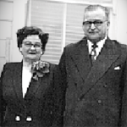
President and Sister Hilton A. Robertson were first called as a young couple to the Japanese Mission in 1921. When the missionaries were withdrawn from Japan due to the unsettled political conditions, Elder Robertson was the Presiding Elder in the Mission.

They made a home in Springville Utah, after returning home, and in 1937 they were called to preside over the Central Pacific Mission in Hawaii. Their assignment was to proselyte the Japanese people in Hawaii.

With the outbreak of the War with Japan, President and Sister Robertson returned to Springville to continue their business and political activities. President Robertson was a Stake President, County Commissioner, and one of the few Utah County Democrats.

In 1949, they were called to open up the Chinese Mission, and in July 1949, they accompanied Elder Matthew Cowley to China (Guangzhou). Observing that the political conditions would not permit missionary work in China, they established headquarters at 345 Prince Edward Road, Kowloon City, in Hong Kong. In 1951 the Chinese Mission was transferred to Hawaii, and later to San Francisco, California.

When the Mission was suspended in 1953, President and Sister Robertson were called to preside over the Japanese Mission in Tokyo, Japan. They served there during the Korean War and were a great spiritual influence among the many LDS Servicemen that were in that area. They were released in 1956, and returned to Provo, Utah. They were truly missionary pioneers. When the call came to them, they were ready to answer the call. All missionaries who have served in the Hong Kong Mission should look to their pioneer example.

Submitted by H. Grant Heaton

Created: 2002-03-18
Modified: 2002-03-18

President H. Grant Heaton 席得恩
Spouse: Luana C. Heaton

Served: 1955 - 1959
Southern Far East Mission
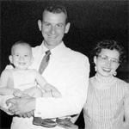
H. Grant Heaton was born June 5, 1929, in the Southern Utah town of Alton. He had four sisters. He was among the first group of missionaries who were called on a mission to the Chinese Mission in Hong Kong in 1949. The Chinese Mission was suspended in 1952 because of the Korean War and so, Elder Heaton enrolled in the University of California, Berkeley, Campus, in a specialized Chinese language class while still serving his mission. President Heaton also attended the University of Utah before and after his mission.

In July, 1952, he was drafted into the U.S. Army. He married Luana Carter, from Park Valley Utah, in December 1952. He was discharged from the Army in May 1954. In July 1955, he was called by President McKay to go with his wife and infant son to open the Southern Far East Mission.

President has been a High Councilman in the North Seattle Stake, 1962-66 Seminary Co-ordinator of Seminaries, Puget Sound District, 1960-64 Direrctor of LDS Institute, University of Washington, 1964-66. Special Calling from President Kimball to review and plan revision of all Church literature in Chinese, 1978-80. Name Extraction Specialist, Family History mission.

Sister Luana Heaton was born in Park Valley, Box Elder County, Utah. In August 1949, Luana was called to serve in the newly opened Southwest Indian Mission in New Mexico when she was just 20 years old. She has also served in the California Mission in the Arcadia area.

They currently reside in Salt Lake City, Utah and have five children, twenty-four grandchildren, and one great grandchild.

Mission President Profile: H. Grant and Luana Heaton

President H. Grant Heaton was born June 5, 1929, in the Southern Utah town of Alton. He had four sisters. He went to school for seven years at Alton Elementary School. He then rode a bus to Orderville Utah, to attend Valley High School. He graduated in 1947.

He enrolled at the University of Utah in 1948, was called on a mission to the Chinese Mission for a term of four years in 1949. He was the first Elder called to this mision.President Hilton A. Robertson was mission president of this mission.

The Chinese Mission was suspended in 1952. Elder Heaton enrolled in the University of California, Berkeley, Campus, in a specialized Chinese language class.

In July, 1952, he was drafted into the U.S. Army. He married Luana Carter, from Park Valley Utah, in December 1952.

In January, 1953 he was assigned to Korea where he worked with the United States and United Nations Intelligence services, and with the Prisoner of War command. His assignment was to work with Chinese war prisoners who had either been captured or who had defected during the Korean war.

He was discharged from the Army in May 1954, and enrolled at the University of Utah and was preparing to move to Seattle Washington, when he was called by President McKay to go, with his wife and infant son to open the Southern Far East Mission, in July 1955.

He was not released from his first Mission by President Robertson until he was on his way to Hong Kong as President of the Southern Far East Mission. Although he served in the army in Korea, he still worked under President Robertson, his former Mission President, who had been assigned as President of the Japanese Mission. They had great success in Korea, working with hundreds of Korean students and assisted by Dr. Kim, Ho-Jik. He always considered his military service to be a continuation of his Mission, which was cut short because of the Korean War. His original call to the Chinese Mission was for 4 years. Including Korea, he did serve four years before he was handed his release.

Sister Luana Heaton was born in Park Valley, Box Elder County, Utah, January 30,1929. She attended Park Valley Elementary School through the 8th grade. She then attended Bear River High School in Tremonton Utah for one year. Her final two years of High School education was at Box Elder High School in Brigham City Utah. She graduated in 1947. She enrolled at the University of Utah in the Fall of 1947.

Grant and Luana met at the University of Utah. They both attended a dancing class and were attracted to each other. A casual courtship ensued.

In August 1949, Luana was called to serve in the newly opened Southwest Indian Mission in New Mexico. She was just 20 years old. At that time, sister missionaries were not called until they were 23. She left for the mission field in October, 1949.

Grant received a call to serve four years in the Chinese mission, in September 1949. (That mission was just in the process of being opened.

Luana was released from her mission in July 1951, and began teaching school at the Park Valley, Elementary School.

Grant came home from the mission field in June, 1952. He was soon drafted into the Army.

Grant and Luana were married on December 19,1952, while Grant was on furlough before being sent to Korea, where he served with Military Intelligence and Prisoner of War Command for 17 months.

While Grant was in Korea, Luana was called to serve in the California Mission in the Arcadia area. She was released in April and was home when Grant returned from Korea in May, 1954.

Grant enrolled at the University of Utah, and they were preparing to move to Seattle Washington to attend the Far Eastern Institute study program. Their first child, Grant Heaton Jr. was born in March 1955.

President and Sister Heaton were called to open the Southern Far East Mission in May, 1955. They were then just 26 years old. They served in the mission field until December 1959. Two more children were born while they were in the mission field, Lisa Lee Heaton, and Eric Eugene Heaton,

After returning home, they moved to Seattle, Washington where Grant enrolled in the University of Washington. He also helped to open up the Early Morning Seminary program in the Puget Sound area, as Seminary Coordinator for that area. He also served as Institute Director for the LDS Institute at the University of Washington for several years. He was an assistant lecturer and teacher at the Far East Studies Institute for three years. He taught briefly at the Brigham Young University in 1962

In 1968, the Heatons, who now had two more children, Kwan Carter Heaton, and Patricia Anne Heaton, returned to Salt Lake City, where they have resided since that time. They have made their home in Holladay Utah.

Grant Heaton has been involved in various business ventures in the United States, China, Singapore, Taiwan, Hong Kong and Japan. Luana has accompanied him on many of his extended trips to China from 1982-1993. They are currently retired.

Created: 2002-03-15
Modified: 2003-04-02

President Robert S. Taylor 泰來羅拔
Served: 1959 - 1962
Southern Far East Mission

A businessman from Hawaii. Assumed leadership of the Southern Far East Mission on September 15, 1959.

Created: 2002-03-17
Modified: 2002-03-17

President Jay A. Quealey 奎理
Served: 1962 - 1965
Became President of the Southern Far East Mission in September of 1962. Former Oahu Stake president

Created: 2002-03-17
Modified: 2002-03-17

President Keith E. Garner 賈納
Served: 1965 – 1968
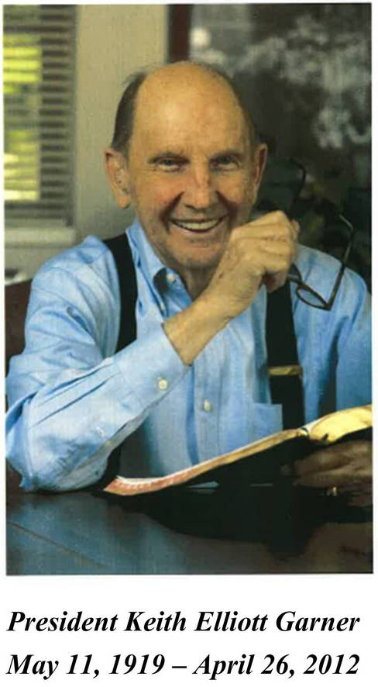
Originally from Palo Alto, California. Became President of the Southern Far East Mission in August 1965. First contacts with the Chinese people during his mission to the Hawaiian Islands.
Passed away on April 26, 2012

Created: 2002-03-17
Modified: 2002-03-17

President W. Brent Hardy 哈迪
Spouse: Elaine
Served: 1968 – 1971
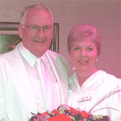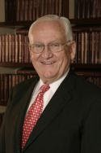
W. Brent Hardy was born on October 14, 1933 in La Verkin, Utah. He served his mission in the Southern Far East Mission from 1956 to 1959. At that time, the mission included the entire southeast Asia area and so, President Hardy had the opportunity to serve in Hong Kong, Taiwan, Guam, and visit the Philippines. President Hardy became the Mission President of the Southern Far East Mission in 1968 and finished as President of the Hong Kong Mission in 1971. The mission was divided three times during that period of time (see History). President Hardy graduated from Hurricane High School and earned a degree in Economics at the University of Utah. He also served in the Army for two years.

President Hardy has been Bishop, Regional Representative and Mission Representative of the Twelve for Taiwan, Hong Kong and Vietnam Regions, Stake Patriarch for North Las Vegas, Youth Sunday School Teacher (17 year olds) 26 years continuously. Called as a sealer in 1989. He is currently the Temple President of the Hong Kong Temple.

Sister Elaine Taylor Hardy was born July 1, 1935 in Ogden, Utah. Sister Hardy also served in the Southern Far East Mission from 1958 to 1960. She graduated from Weber High School and attended Utah State University. Sister Hardy has served as Spiritual Living instructor, Gospel Doctrine teacher, Primary, Young Women, Secretary for Patriarch 24 years, Companion to the mission president, and Hong Kong China Temple Matron.

President and Sister Hardy were married in the Salt Lake Temple and now have five children -- Dianne, Warren, Rebecca, Hance and Jared -- and twenty-three grandchildren.

(Submitted by President Grant Heaton)

Created: 2002-03-15
Modified: 2008-05-07

W. Brent Hardy (哈迪會長) 有一篇長文報導，在「50周年書」檔案夾內

President Malan Robert Jackson 翟新倫
Spouse: Linda
Served: 1971 - 1974

Sister Jackson and I are both retired now but still spending a lot of time in Asia, mostly Mongolia. doing humanitarian projects. We have 23 grandchildren, all living in Utah. Nothing thrills us more than hearing from missionaries we served with in Taiwan. I currently serve in a branch presidency in the Missionary Training Center.

Created: 2002-03-14
Modified: 2002-03-14

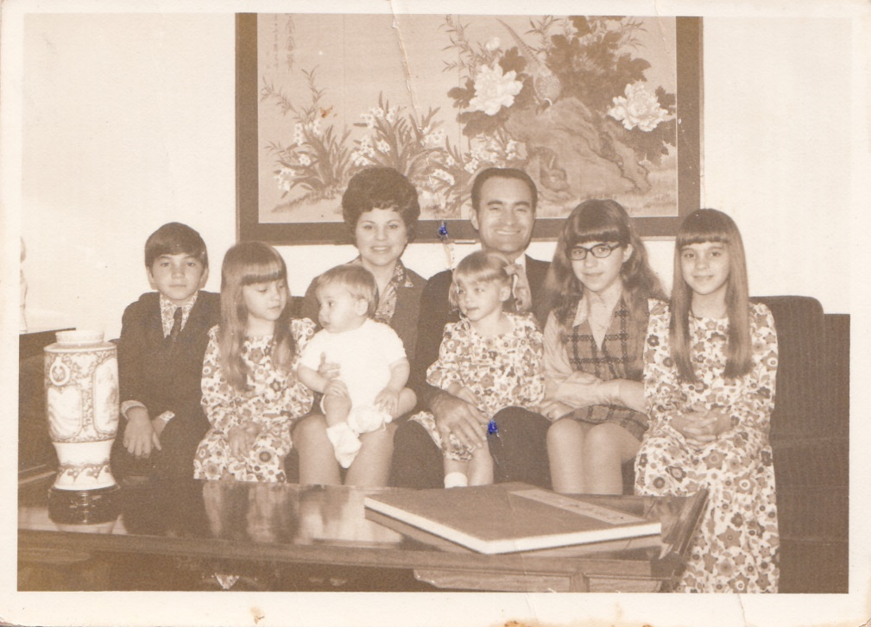
翟新倫會長家庭 President Malan Jackson’s Family
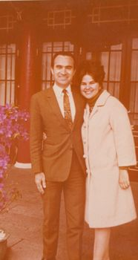
President and Sister Jackson in 1971 at a Mission Conference

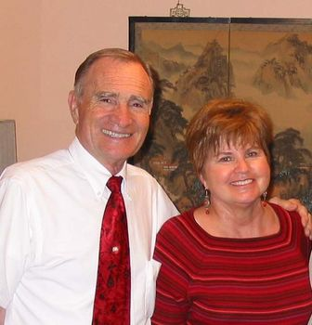

President Thomas P. Nielson 倪爾遜
Spouse: Bonnie
Served: 1974 - 1977
Associated Alumni
November 2003, we were released as Taipei Temple President and Matron. We are back at our home in Michigan, where we are serving as sealer and ordinance worker in the Detroit Temple.

Created: 2002-03-13
Modified: 2004-06-05
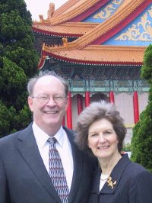

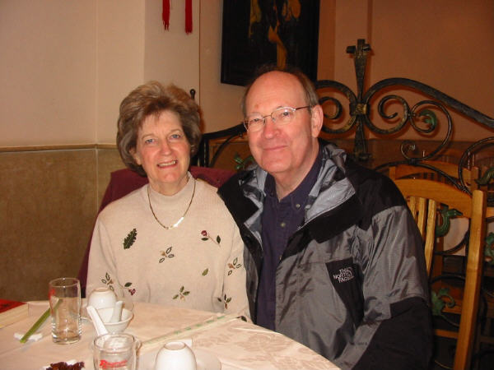
President & Sister Thomas Nielson at the Grape Restaurant, Shanghai, 2003

President Frederick W. Crook 郭志文
Spouse: Elizabeth Crook
Served: 1977 – 1979

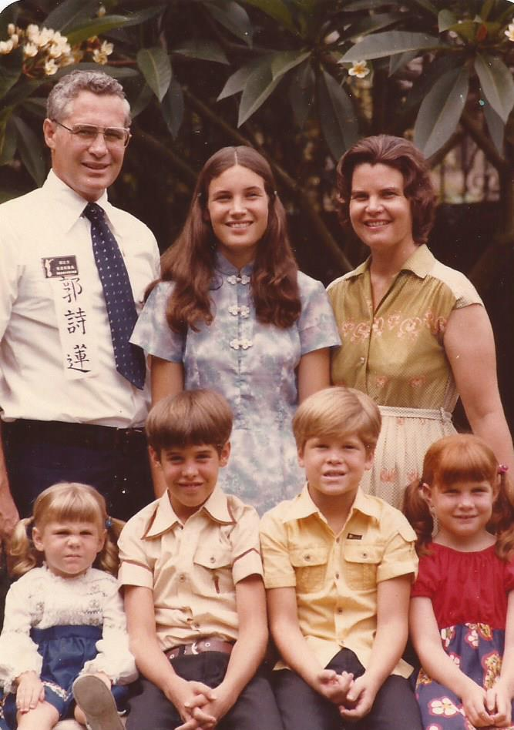

Hi Taiwan Missionaries,

After many years in the East, Elizabeth and I have moved to Alpine, Utah. We are delighted to be nearer many of you!

As many of you know, I spent my career in the US Department of Agriculture traveling in rural areas of China. I was moved many times by the plight of the children in those areas. When I retired in 2000, I established a foundation--The China Rural Education Foundation (CREF)-- to help these children pay their fees. I discovered that only $40 a year will keep a child in school in these areas!

We have "adopted" two village schools in Gan Quan County, Shaanxi Province. I have traveled to visit the schools, students and parents many times. A number of returned Taiwan missionaries have also visited the schools. If you would like to help, send me an email. We need help with the website, writing letters in Chinese to students, translating letters from students to donors, studying rural educational conditions and helping with our annual fund raiser during Chinese New Years at Utath Valley University. Check out the website at www.thecref.org.

I continue to read the Book of Mormon in Chinese. I have read both the jian ti and fan ti versions. I have completed a rough draft of a glossary of terms (character compounds that some returned missionaries might not be familiar with). Hopefully at some point in time the glossary will be of some help.

President Frederick W. Crook

Created: 2002-03-27
Modified: 2008-12-31

President Douglas H. Powelson 鮑華生
Served: 1979 - 1982
Created: 2002-03-13
Modified: 2002-03-13
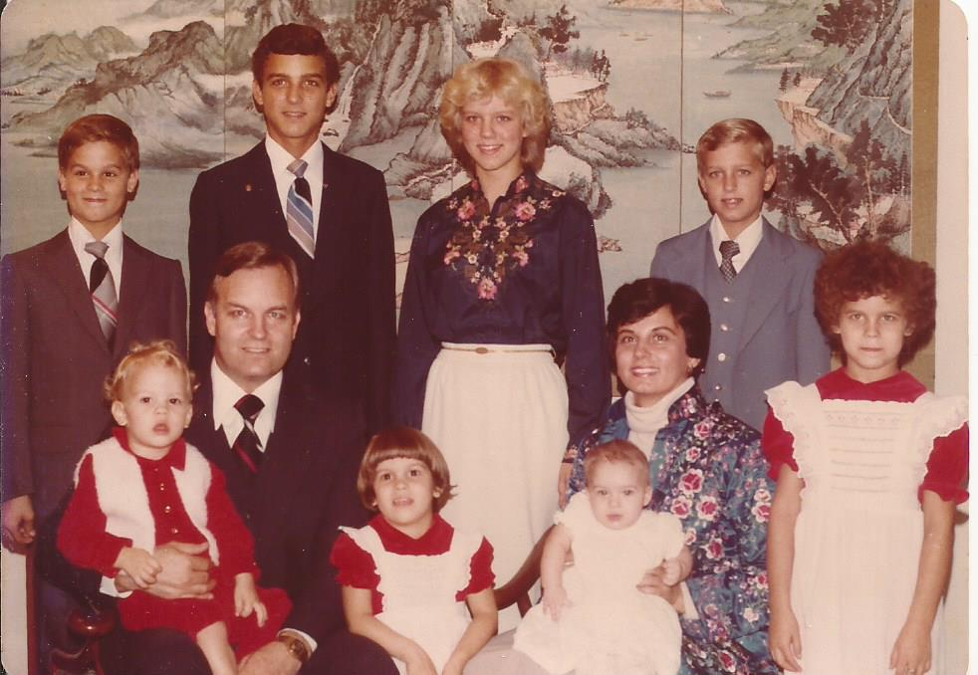
鮑華生會長家庭

President Paul V. Hyer 海爾保羅
Served: 1982 - 1985
Mission Presdent - Taipei - 1982-1983
Temple President - Taipei - 1988-1990
BYU Professor 1957 to present
Currently, Executive Director, International Society

Created: 2002-03-13
Modified: 2002-03-13

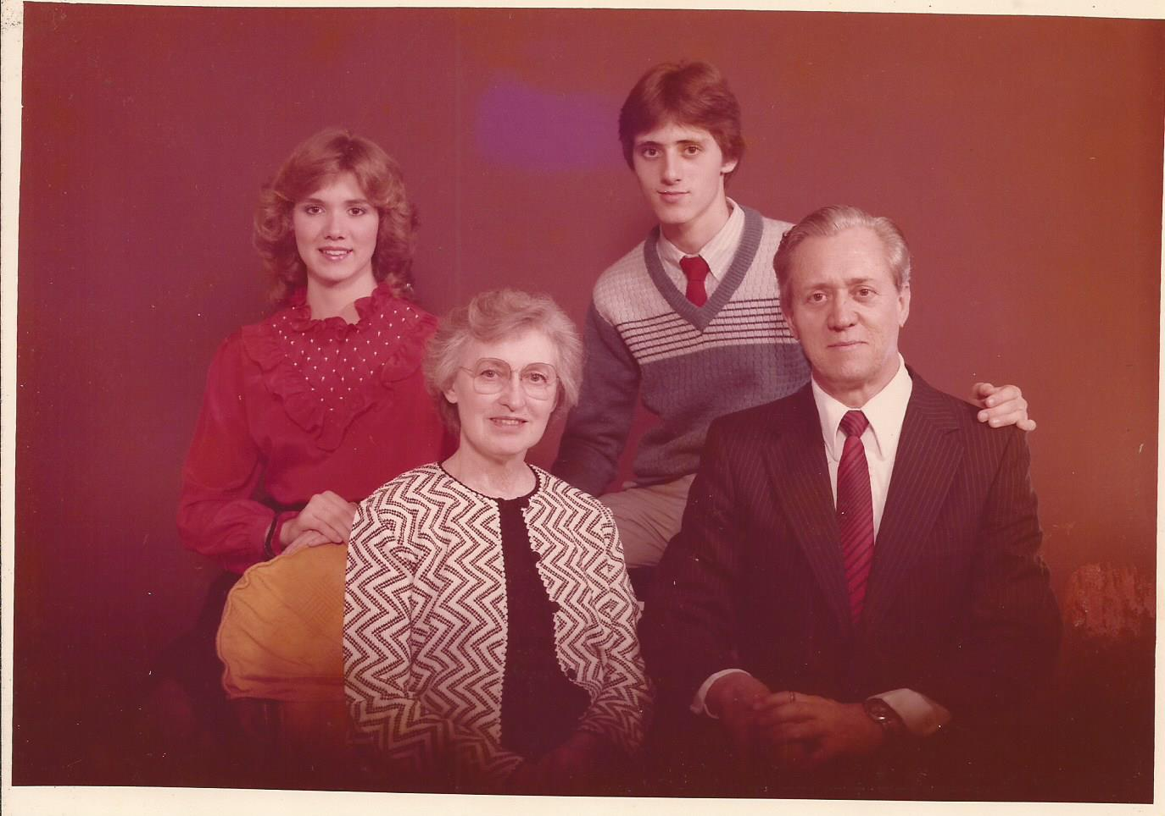
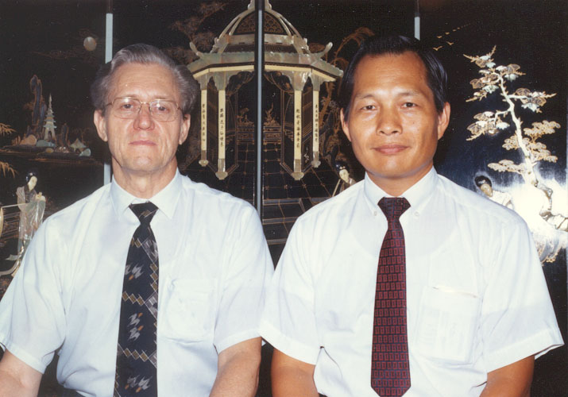
Pres. Paul V. Hyer passing baton to Pres. Larry Y. C. Chen (July, 1985

President Larry Y. C. Chen 陳勇助
Served: 1985 – 1988
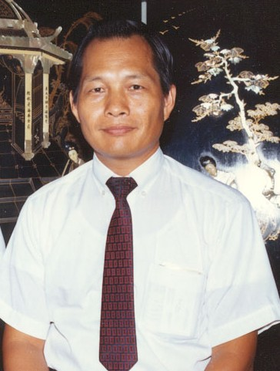
Photo courtesy of William T. Caine.

Created: 2002-03-13
Modified: 2002-03-13
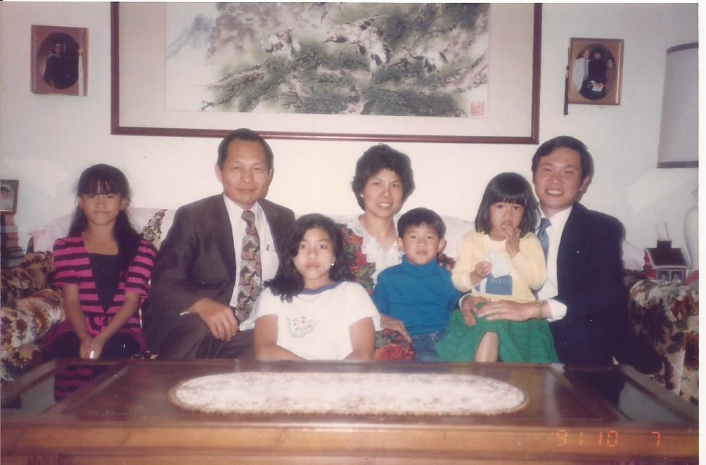

President Patrick H. Price 江培士
Spouse: Charlotte
Served: 1988 – 1991
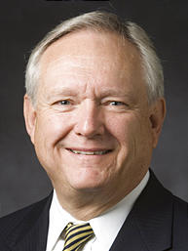
Patrick H. Price, 61, Salt Lake City, Utah; project manager, MWH Americas Inc.; president of the Salt Lake University 5th (Student Single) Stake; former mission president, stake president's counselor and bishop. Wife, Charlotte; three children. Called as a new Area Seventy in April, 2007.

Created: 2002-03-13
Modified: 2005-11-14

President Harvey G. Horner 賀中正
Served: 1991 - 1994
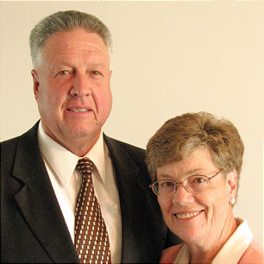
Harvey Glade Horner, 64, Heber 4th Ward, Heber City Utah Stake, called as president of the Taipei Taiwan Temple, succeeding President Gerald H. Walker. President Horner's wife, Sherry Wilson Horner, will serve as temple matron. President Horner is the managing director of the Church's Heber Valley Girls Camp and former president of the Taiwan Taipei Mission, stake president, stake executive secretary, high councilor, bishop and temple ordinance worker. A retired public school administrator, he was born in Heber City, Utah, to Glade Brown and Yvonne Hicken Horner.

A stake Relief Society president, Sister Horner served with her husband as he presided over the Taiwan Taipei Mission. She served as a ward Relief Society president, ward Primary president, counselor in ward Relief Society and Young Women presidencies and as a temple ordinance worker. She was born in Heber City, Utah, to Emer Huffaker and Leah Henrie Wilson.

Created: 2002-03-13
Modified: 2008-02-25

President Richard B. Stamps 尹因印
Served: 1994 – 1997
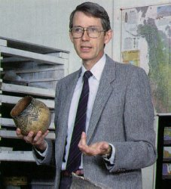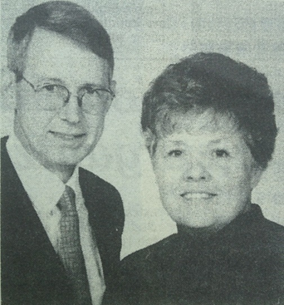
Pres. Stamps visited China again this year in May and August. The trip in
May led a Study Tour of 17 people for 17 days. All but 2 were LDS so we
went to church in Beijing, Shanghai and Hong Kong. China continues to
change at a rapid rate. The trip in Aug was a business visit to several
factories near Shen Zhen. The growth is unbelievable.
Have you all seen the new, updated translation of the Book of Mormon ? The
Three in One. New terms--Mo erh men. Sounds good .Nice job Sis Huang and
all involved.
Pres. and Sister Stamps continue to live and work just north of Detroit,
Michigan.
Keep up the good work.
Pres. Stamps

Created: 2002-03-10
Modified: 2002-03-10

尹因印會長來自美國密西根州，曾在台灣傳教，來台擔任台美傳道部會長時51歲。他是奧克蘭大學的人類學家暨考古學家；陸軍少尉；獲有楊百翰大學考古學戶亞洲研究之學士及碩士學位,以及密西根州立大學之博士學位；在教會曾擔任支聯會副會長，福音進修班教師，主教，高級諮議及支會傳道領袖等職務。

尹姊妹(Marsha Iverson Stamps)生於猶他州鹽湖城，曾就讀楊百翰大學，獲有奧克蘭大學企業和電腦學士學位；為某報社前會計主管；在教會曾擔任婦女會會長及副會長，女青年顧問，活動主席，主日學教師等職務。

尹因印夫婦育有五位子女。

President Michael G. Harris 胡念中
Spouse: LindaGay
Served: 1997 - 2000
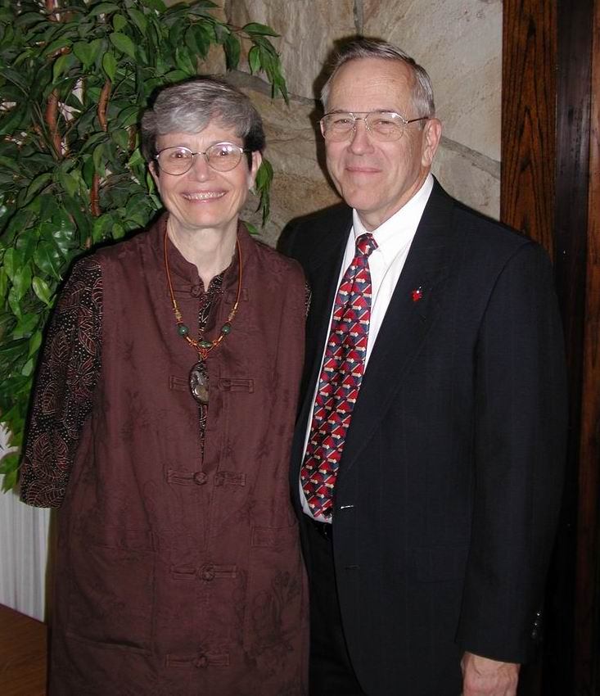
Michael G. Harris, 59 when called, Camarillo 5th Ward, Camarillo California Stake; stake missionary; former stake president's counselor, high councilor, bishop and counselor, elders quorum president, and missionary in the Southern Far East Mission; high school teacher and art department chairman; received bachelor's degree in art education and master's degree in printmaking and design, both from BYU; born in Ventura, Calif., to Arlo William and Marguerite Fisher Harris; married LindaGay Dean, three children.

Sister LindaGay Harris was a stake missionary; former stake Relief Society board member, ward Relief Society president and counselor, Primary president, inservice leader, Cub Scout leader, and Relief Society teacher; received bachelor's degree in art from BYU; born in Pomona, Calif., to John O. and Marguerite Christina Lundgrene Dean.

Created: 2002-03-10
Modified: 2002-03-10

President Edward James Phipps 馮德書
Served: 2000 - 2003
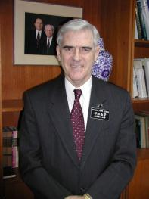
Edward James Phipps, 57, Morialta Ward, Adelaide Australia Firle Stake; was a missionary serving with wife in Taiwan Taipei Mission, former high councilor, stake Young Men president, counselor in mission presidency, district president, stake president's counselor, stake mission president; retired chief executive of South Australian Water Corp., received MBA from University of Melbourne; born in Melbourne, Australia, to Francis James and Edna Maisie Williams Phipps; married Margaret Rose Bunney; two children.

Sister Margaret Phipps was a missionary serving with husband in Taiwan Taipei Mission, former Primary teacher, Sunday School gospel doctrine teacher, Relief Society teacher, stake Primary president, counselor in stake Relief Society presidency, nursery leader and ward Relief Society president; primary school teacher, received diploma of teaching at Geelong Teachers College; born in Casterton, Australia, to Thomas Joseph and Doris Grace Fitzgerald Bunney.

Created: 2002-04-02
Modified: 2004-06-24

President Anthony Duane Perkins 潘望博
Spouse: Christine Dee Perkins
Served: 2003 - 2006
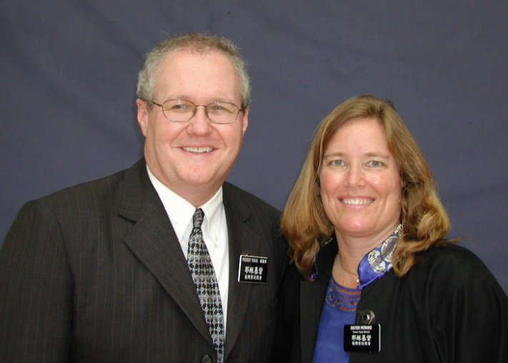
Anthony Duane Perkins, 42, Taiwan Taipei Mission; Most recently served as the branch president in the Beijing Branch, China International District. Former counselor in a district presidency, counselor in branch presidency, elders quorum president, Sunday School teacher, seminary teacher and missionary. Senior partner in McKinsey & Co. Born in Cortez, Colorado to Larry Lazelle and Sunny Kimballa Luther Perkins. Married to Christine Dee Abbott. They are the parents of six children.

Christine Perkins is currently serving as the branch Young Women president and was a former branch Primary president, counselor in ward Young Women presidency, counselor in ward Primary presidency, nursery leader, Primary teacher and organist. Born in Farmington, N.M., to Bob Walter and Janice Hilton Abbott.

Created: 2003-04-02
Modified: 2003-04-02

President Norman Sanford Nielson 王孝賢
Spouse: Mary Louise Wolsey
Served: 2006 - 2009
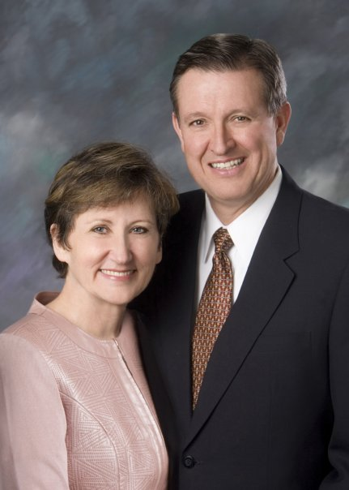
Norman Sanford Nielson, 53, Monticello 1st Ward, Monticello Utah Stake; Aaronic Priesthood adviser; former counselor in a stake presidency, bishop, counselor in a bishopric, high councilor, counselor in a stake young men presidency and missionary in the Taiwan mission. Staff physician at Utah Navajo Health Systems. Born in Durango, Colo., to Norman Floyd and Ruth Mary Jones Nielson. Married Mary Louise Wolsey, six children.

A ward organist, Sister Nielson is a former ward young women and relief society president, counselor in a ward primary presidency, stake and ward music chairman, young women adviser and stake cultural arts specialist. Born in Salt Lake City, Utah, to Heber Grant and Fay Parrish Wolsey.

Created: 2006-03-05
Modified: 2007-04-11

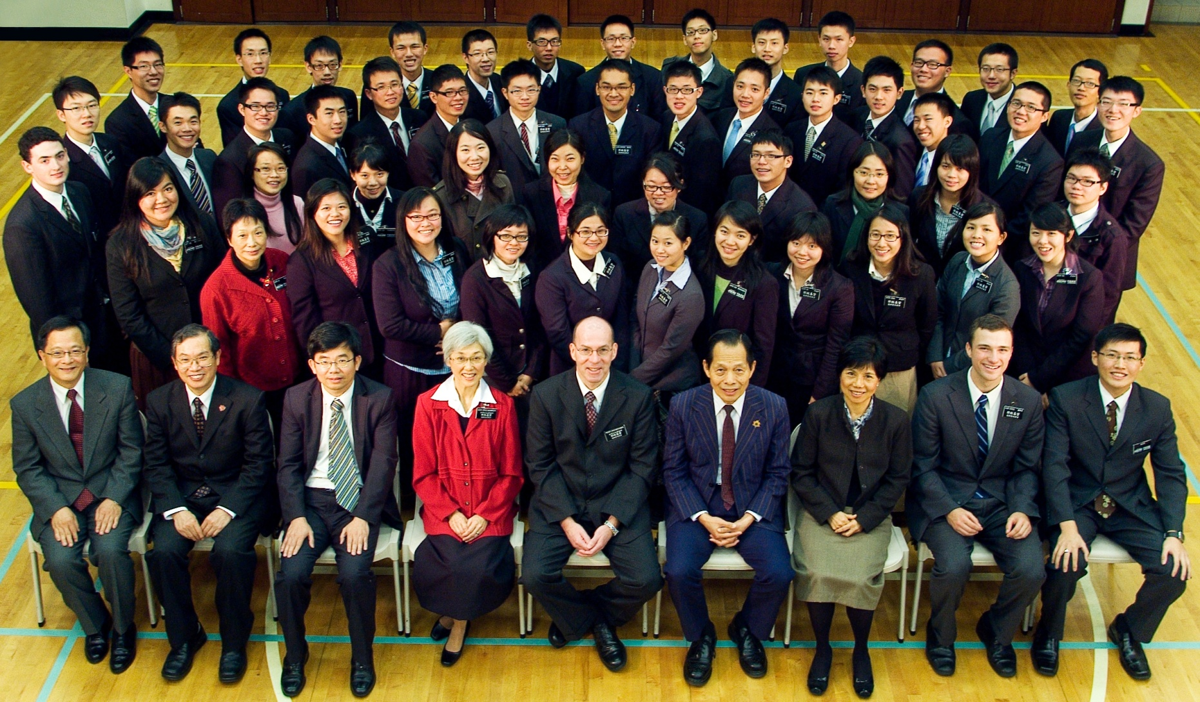

葛忠信會長時的本地傳教士合照
President David Owen Day 范仲雁
Spouse: Vicki
Served: 2012 – 2015
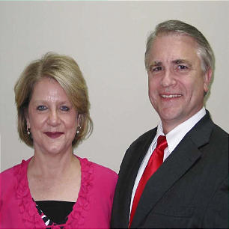
David Owen Day, 53, and Vicki Temple Butler Day, five children, Burgess Falls Ward, McMinnville Tennessee Stake. Brother Day serves as a counselor in a stake presidency and is a former stake clerk, stake mission president, bishop, gospel doctrine teacher, ward mission leader, elders quorum president, Young Men president and missionary in the Taiwan Taipei Mission. President and owner, Law Office of David Day, P.C. Born in Long Beach, Calif., to Robert Owen and Linda Sue Day.

Sister Day serves as a counselor in a Relief Society presidency and as a stake Young Women camp director. She is a former seminary teacher, Young Women president, counselor in a Primary presidency, Sunday School teacher and Primary music leader. Born in Greenville, Miss., to James William and Virginia Millis Holmes Butler.

Created: 2013-06-30
Modified: 2013-06-30

傑佛瑞賀倫長老與台北傳道部傳教士-20140226

President Jace B. Jergensen 江耀雲
Spouse: Jennifer M.
Served: 2015 – 2018
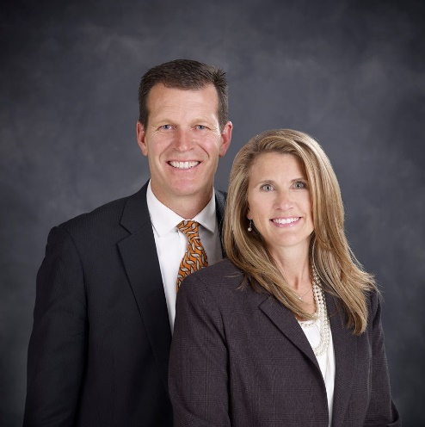
Jace Bart Jergensen, 52, and Jennifer McOmber Jergensen, six children, Fox Ridge Ward, River Heights Utah Stake: Taiwan Taipei Mission. Brother Jergensen is a former stake presidency counselor, bishop, bishopric counselor, stake Young Men president, and missionary in the Taiwan Taipei Mission. Senior vice president, Icon Health & Fitness. Born in St. Anthony, Idaho, to Rey L. Jergensen and Faye Waldram Jergensen VanLeeuwen.

Sister Jergensen is a former ward Young Women and Primary president, ward Primary and Young Women presidency counselor, Gospel Doctrine teacher, and Young Women adviser. Born in St. George, Utah, to Emerson Tindal McOmber and Rhea Kaye Tobler McOmber.

Created: 2015-06-03
Modified: 2015-06-03

台北傳道部會長 江耀雲

http://www.lds.org.tw/%E4%BA%BA%E7%89%A9%E5%B0%88%E8%A8%AA%E5%8F%B0%E5%8C%97%E5%82%B3%E9%81%93%E9%83%A8%E6%9C%83%E9%95%B7-%E6%B1%9F%E8%80%80%E9%9B%B2
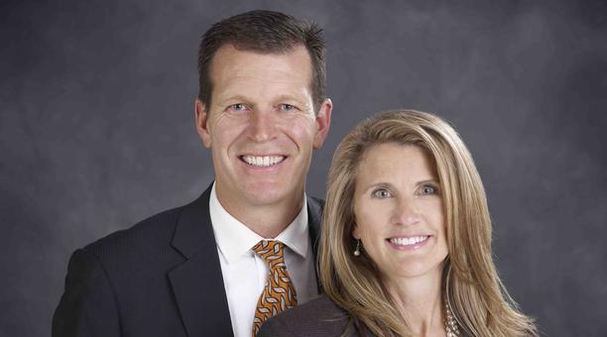
呂謝孟娟
闊別台灣33年的江耀雲會長(Jace Jergensen )，這次以台灣台北傳道部會長的身分，在2015年7月1日與江穎貞(Jennifer Jergensen )姐妹和最年幼的雙胞胎兒子一同來到台灣。

江會長於1962年12月11日在美國愛德華洲出生，隨後全家移居至猶他州長大。他在1982-1983年在台灣台北傳道部擔任全部時間傳教士，由當時的Powelson和Hyer擔任傳道部會長。返鄉後在楊百翰大學就讀，認識來自加州的江穎貞姊妹，並於1984年結婚，育有六子。1987年大學畢業，1989年在楊百翰大學企業管理碩士畢業，1989-1994在Maryland和新加坡的Black and Decker公司工作，1994-2015年在猶他州北部的Logan經營Icon Health & Fitness健身器材公司。

江會長談到接受傳道部會長的召喚讓他感到非常榮幸，他在總會接受到指示要幫助達到當地支聯會設立的新歸信者目標。他期待成員可以和傳教士合作，達到：「教導悔改、洗禮歸信者。」的目標，而成員最能幫助傳教士的事情就是介紹回條。要達到這個目標，他表示首先成員需要在朋友、鄰人、家人之中做好榜樣，第二在適當的機會和他們分享福音，第三開口邀請他們來到教會或是一起參與家人家庭晚會，最後幫助他們成為傳教士有效的回條。

江姊妹負責英文班部分，在台灣台北傳道部英文班人數，每星期都可以達到將近1000人，是一個很成功的活動。英文班前一個小時學習英文，最後半個小時學習福音。每六週會有一個好玩的英文班活動，成員可以介紹朋友來英文班，並陪伴他們。也可以在門口迎接新來的朋友，帶他們到所屬的班級上課。英文好的成員可以和傳教士分開上課，讓只有一、兩組傳教士的地區可以多一兩個班級，也可以讓學生人數多的班級分成數小班上課，使上課品質可以更好。有本地的成員協助傳教士分開上課，在後面半小時的福音學習，他們也可以更容易和非成員分享，並找出有興趣的人和傳教士見面上課。英文班的上課技巧也將會改進，並且設計不同的教材，讓真正想學習英文的人可以不斷來上課。

台灣台北傳道部目前有194位傳教士，本地傳教士有15位，江會長希望可以有更多台灣年輕成人能準備好來傳教，台灣台北傳道部需要他們。
圖片圖說 台北傳道部會長江耀雲和妻子江穎貞姊妹

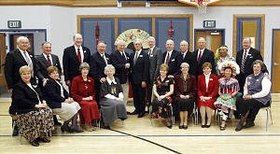
Former presidents of missions in Taiwan attending Salt Lake City reunion, many with their wives, were, from left, W. Brent and Elaine Hardy, Malan R. and Linda Jackson, Thomas P. and Bonnie Nielson, Boyd and Lyona Hales, Frederick W. Crook, Pau. Photo by Keith Johnson© Deseret Morning News

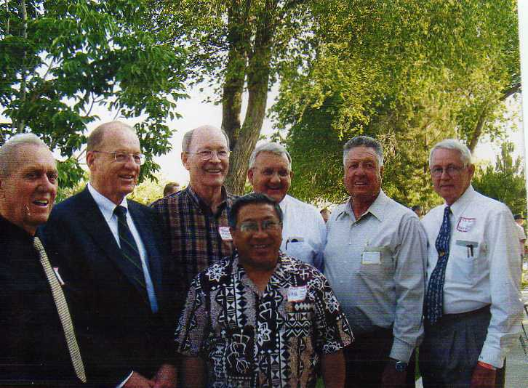
七位傳道部會長

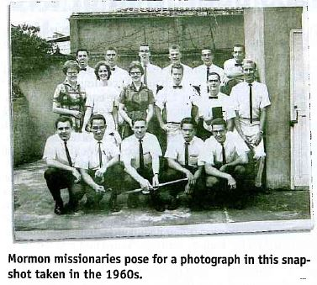

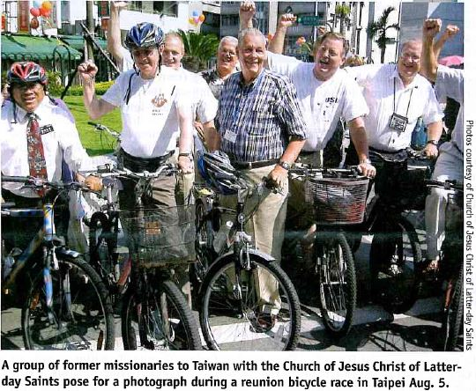

2摩門傳教士一氧化碳中毒亡

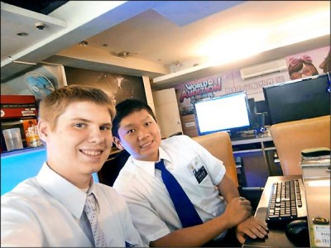
中時電子報作者陳宜加╱新北報導 | 中時電子報 – 2014年8月24日 上午5:50
24歲男子熊宇鵬、19歲美國籍男子班傑明，2人為摩門教傳教士，23日被發現陳屍於三重租屋處，屋內門窗緊閉、冷氣與浴室水龍頭未關，警消初步排除他殺，研判為陽台熱水器燃燒不完全，導致一氧化碳中毒身亡。
23日上午10時許，三重消防隊獲報，指稱新北大道一段某處社區大樓2樓公寓，有2人昏迷。趕抵現場發現熊宇鵬及其夥伴康納班傑明（Connor Benjamin）倒臥住處，已明顯死亡多時，身上無外傷。
報案人指出，22日下午便聯絡不上兩人，昨天到他們租屋處也無人應門，於是找鎖匠協助開門，發現門窗緊閉、屋內冷氣與浴室用水未關，班傑明坐在臥室床邊地上、熊宇鵬倒臥浴室，都沒有生命跡象，嚇得連忙報案。
消防隊調查，熱水器與冷氣皆安裝於後陽台，屋主卻將陽台外推為廚房，並加裝玻璃窗，形成密閉空間，疑為前晚兩人洗澡時，開冷氣、緊閉門窗，導致一氧化碳無法排出，循環進入室內，中毒身亡。
警方調查，熊宇鵬與班傑明為摩門教傳教士，班傑明來台僅3個月。兩人為同組夥伴，居住於教會租賃的20坪公寓，每日傳教超過12小時。
當地住戶表示，兩人所屬教會數年前租下公寓，供駐地傳教士輪流居住，兩人平時逢人便投以笑容招呼，更不時哼著歌，如今枉死，深感惋惜。
李姓教友表示，熊宇鵬入教時間久，因堅定為上帝服務的心，自願成為傳教士。「熊長老」樂觀、開朗，待人親切，不時主動關懷教友。曾透露結束為期2年的傳教士工作後，計畫繼續求學，是個懷抱理想與衝勁的人。

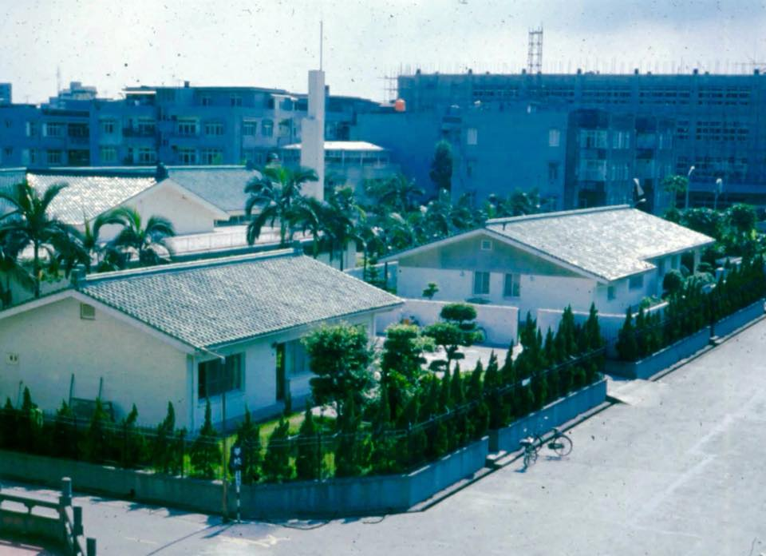

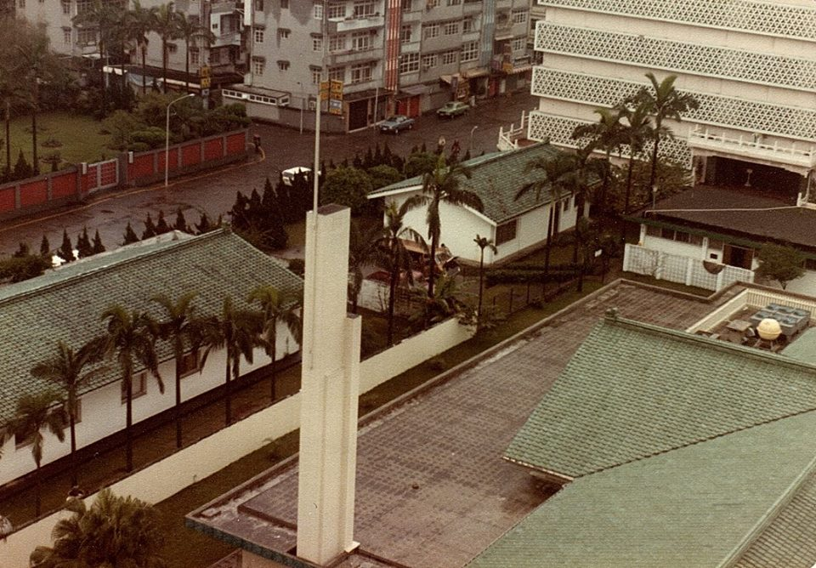

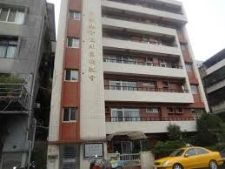

台北傳道部 –
台北市金華街183巷24號四樓

補充資料提供者姓名： 電話： Email：

